CORAI -
Biograpies of Speakers

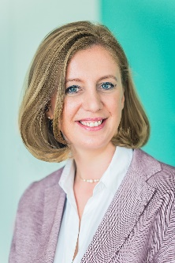 |  | Barbara Eibinger-Miedl  Barbara Eibinger-Miedl, was elected president of the Committee of the Regions interregional group “Future of the Automotive Industry (CoRAI)” in July 2018. As an active member of the CoR she focuses her work in Brussels on the Commission for Economic Policy, specifically on Small and Medium Sized Enterprises. Barbara Eibinger-Miedl is Minister of the Austrian province Steiermark for Economic Affairs, Tourism, European and External Relations, Science and Research since April 2017. Previously she was chairing the parliamentary group of the Austrian Peoples Party in the Steiermark-Parliament. Additionally she was speaker for Constitutional, European and External Relations. She started her political career as member of a local council, led the initiative “Women in business” and was head of the European Office in Graz.
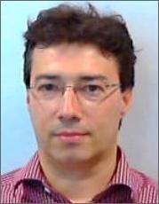 |  | Fabrizio Sacchetti  Fabrizio Sacchetti is a member of the European Commission's Brexit Task Force, where he is responsible for regulatory aspects of trade in goods, industrial sectors, standardisation, research and innovation. Previously, he held various positions in the Directorates-General for 'Internal Market, Industry, Entrepreneurship and SMEs' (2015-2017) and 'Enterprise and Industry' (2003-2015) in the areas of internal market for goods and technical barriers to trade. Before joining the European Commission, he practised law in Brussels with Coudert Brothers LL.P, specialising in EU and international trade and customs law (1997-2003). He is a qualified lawyer, admitted to the Bologna Bar (Italy) in 1999. He holds a degree in law from the University of Bologna (1995) and LL.M diplomas from the University of Nijmegen (the Netherlands, 1996) and the College of Europe in Bruges (Belgium, 1997).
Erik Jonnaert
Erik Jonnaert is the Secretary General of the European Automobile Manufacturers’ Association (ACEA), a position he has held since July 2013. ACEA brings together the 15 major manufacturers of passenger cars, vans, trucks and buses with production in the EU: BMW Group, DAF Trucks, Daimler, Fiat Chrysler Automobiles, Ford of Europe, Honda Motor Europe, Hyundai Motor Europe, Iveco, Jaguar Land Rover, PSA Group, Renault Group, Toyota Motor Europe, Volkswagen Group, Volvo Cars, and Volvo Group. In addition to his ACEA posting, Mr Jonnaert is currently chairman of the steering committee of EATA, the European Automotive and Telecom Alliance, which aims to accelerate the deployment of connected and automated driving. Mr Jonnaert is also on the Supervisory Board of ERTICO (advocating intelligent mobility solutions) and on the Board of the Mobility as a Service (MaaS) Alliance. A Belgian national, Mr Jonnaert holds masters in law from the University of Ghent, Belgium and from Harvard Law School, USA.
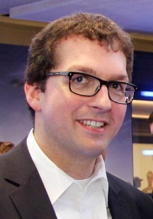 |  | Maurus Unsoeld  Dr. Maurus Unsoeld is Deputy Head of Office for the BMW Group in Brussels. He is responsible for all horizontal issues affecting BMW Group at EU level including trade & industrial policy, Brexit and financial market regulation. Until November 2013 he was Manager Economics & Trade in the Corporate Strategy Department of BMW Group. Before joining the BMW Group in 2011, he was Manager Economic & Market Intelligence at Daimler AG and Lecturer for Economics at the Cooperative State University Stuttgart. He holds a Bachelor and Master degree in International Economics and Political Science from the Eberhard-Karls-University Tübingen, Germany and a PhD in Economics from the University Duisburg-Essen, Germany.

